**BLACK-KING**

**FRIENDS, I GREET YOU ALL*!***

**GET INFO: chat or call +234 916 305 3787**

**https://t.me/Black_king207**

**> COURSE OUTLINE**

**1:**

**- Introduction to Forex Trading**

**- Gain an understanding of the global Forex market and how it operates**

**- Examine currency pairs and their dynamics**

**- Learn about Forex trading sessions and market hours**

**- Navigate Forex terminology related to market sentiment**

**- Discover the different analysis methods**

**2:**

**- Maximizing Trading efficiency with MT4 and broker integration**

**- Explore lots, pips, spread, bid and ask prices in more depth**

**- Develop effective trading orders and strategies**

**- Calculating Pip Value for Different Lot Sizes**

**3:**

**- Understanding Margin trading (leveraging)**

**- Understand the importance of risk management**

**- Common Mistakes By Forex Traders**

**- Build a personal trading plan**

**4:**

**- Explore various advanced trading techniques such as scalping, day trading, and swing trading**

**- Learn about technical indicators and their application in trading**

**- Understand fundamental analysis and its role in decision making**

**- Practice Sessions and Case Studies**

**5:**

**- Review and Q&A Session**

**- Recap key concepts covered throughout the training**

**- Address any remaining questions or concerns from participants**

**- Provide guidance on next steps for further learning and development in Forex trading**

**INTRODUCTION TO FOREX TRADING:**

**Forex trading, also known as foreign exchange trading, is the process of buying and selling currencies in the global marketplace. It is the largest financial market in the world, with a daily trading volume exceeding $6 trillion.**

**Forex trading involves the exchange of one currency for another at an agreed-upon price. The goal for traders is to profit from fluctuations in exchange rates between currency pairs. For example, a trader might buy the US dollar (USD) while simultaneously selling the Naira (NGN) if they believe the dollar will strengthen against naira.**

**In summary, forex trading provides opportunities for individuals to participate in the global financial markets and potentially generate profits by speculating on currency price movements. However, it requires education, discipline, and risk management to succeed in this dynamic and fast-paced environment.**

**> CURRENCY PAIRS AND THEIR DYNAMICS**

**In forex trading, currencies are quoted in pairs, with each pair representing the exchange rate between two currencies. Understanding currency pairs and their dynamics is essential for traders to navigate the forex market effectively. Here's an examination of currency pairs and their key dynamics:**

**1. Major Currency Pairs: Major currency pairs are the most heavily traded pairs in the forex market and typically involve currencies from the world's largest economies. Examples include:**

**- EUR/USD (Euro/US Dollar)**

**- USD/JPY (US Dollar/Japanese Yen)**

**- GBP/USD (British Pound/US Dollar)**

**- AUD/USD (Australian Dollar/US Dollar)**

**- USD/CHF (US Dollar/Swiss Franc)**

**- USD/CAD (US Dollar/Canadian Dollar)**

**2. Cross Currency Pairs: Cross currency pairs, also known as minor currency pairs, do not include the US dollar in the pair. Examples include:**

**- EUR/GBP (Euro/British Pound)**

**- EUR/JPY (Euro/Japanese Yen)**

**- GBP/JPY (British Pound/Japanese Yen)**

**- AUD/CAD (Australian Dollar/Canadian Dollar)**

**3. Exotic Currency Pairs: Exotic currency pairs involve one major currency and one currency from a smaller or emerging market economy. These pairs typically have lower liquidity and higher spreads compared to major pairs. Examples include:**

**- USD/SGD (US Dollar/Singapore Dollar)**

**- USD/TRY (US Dollar/Turkish Lira)**

**- EUR/TRY (Euro/Turkish Lira)**

**Base and Quote Currency: In a currency pair, the first currency listed is the base currency, and the second currency is the quote currency. The exchange rate indicates how much of the quote currency is needed to purchase one unit of the base currency.**

**Bid and Ask Prices: Currency pairs are quoted with two prices: the bid price, which is the price at which traders can sell the base currency, and the ask price, which is the price at which traders can buy the base currency. The spread is the difference between the bid and ask prices.**

**Price Movements: The exchange rate of a currency pair fluctuates based on supply and demand dynamics in the market. Factors influencing price movements include economic indicators, central bank policies, geopolitical events, and market sentiment.**

**In summary, forex trading is all about comparing currencies, which is done through currency pairs. These pairs show how much one currency is worth compared to another. Traders use this information to find opportunities to trade and manage risk in the forex market. Understanding the dynamics of currency pairs is essential to succeed in this interconnected market.**

**> FOREX TRADING SESSIONS AND MARKET HOURS**

**Forex trading sessions and market hours refer to the different time periods during which the forex market is open and active for trading. The forex market operates 24 hours a day, five days a week, spanning multiple time zones around the world. Understanding forex trading sessions and market hours is important for timing trades and maximizing trading opportunities. Here's an overview of the main forex trading sessions:**

**1. Asian (Tokyo) Session:**

**- The Asian trading session starts in Tokyo, Japan, and extends to other financial centers in Asia, including Sydney (Australia) and Singapore.**

**- It typically begins at 00:00 GMT (5:00 PM EST) and ends at 09:00 GMT (2:00 AM EST).**

**- Major currency pairs traded during the Asian session include USD/JPY, AUD/USD, and NZD/USD.**

**- Trading activity during this session is often characterized by lower liquidity and volatility compared to other sessions.**

**2. European (London) Session:**

**- The European trading session begins in major financial centers such as London (UK), Frankfurt (Germany), and Zurich (Switzerland).**

**- It overlaps with the end of the Asian session and continues throughout the European business day.**

**- The European session typically starts at 07:00 GMT (2:00 AM EST) and ends at 16:00 GMT (11:00 AM EST).**

**- Major currency pairs traded during the European session include EUR/USD, GBP/USD, and EUR/GBP.**

**- Trading activity during this session tends to be the most active and liquid, with higher volatility and trading volumes.**

**3. North American (New York) Session:**

**- The North American trading session begins in New York (USA) and extends to other financial centers in North America, including Toronto (Canada).**

**- It overlaps with the end of the European session and continues throughout the North American business day.**

**- The North American session typically starts at 12:00 GMT (7:00 AM EST) and ends at 21:00 GMT (4:00 PM EST).**

**- Major currency pairs traded during the North American session include USD/CAD, USD/CHF, and USD/JPY.**

**- Trading activity during this session is influenced by economic data releases, corporate earnings announcements, and market sentiment in the US and Canada.**

**4. Overlapping Sessions:**

**- There are times during the trading day when two sessions overlap, leading to increased trading activity and liquidity.**

**- The most significant overlap occurs between the European and North American sessions, usually between 12:00 GMT (7:00 AM EST) and 16:00 GMT (11:00 AM EST).**

**- During overlapping sessions, traders may benefit from higher trading volumes, tighter spreads, and increased volatility.**

**It's important to note that while the forex market operates 24 hours a day, not all currency pairs are equally active or liquid at all times. Traders should consider the characteristics of each trading session, including liquidity, volatility, and market participants' behavior, when planning their trading activities. Additionally, factors such as economic data releases, geopolitical events, and central bank announcements can impact market sentiment and trading activity across different sessions.**

**> MARKET SENTIMENT:**

**1. Bullish: This is when people feel positive about a currency, they expect its price to go up.**

**2. Bearish: This is when people feel negative about a currency, they expect its price to go down.**

**3. Ranging: This is when prices are staying in a range, not going up or down, just moving within a range.**

**4. Trending: This is when prices are consistently moving in one direction, either upward (bullish trend) or downward (bearish trend)**

**> ANALYSIS METHODS:**

**"Analysis Methods" in forex trading means the techniques and tools traders use to interpret market data and make informed decisions. There are two primary methods:**

**1. Technical Analysis:**

**- Technical analysis involves studying past market data, primarily price and volume, to forecast future price movements.**

**- Traders use various tools and indicators, such as moving averages, trend lines, and oscillators, to identify patterns and trends in price charts.**

**- The goal of technical analysis is to determine entry and exit points for trades based on the analysis of historical price action.**

**2. Fundamental Analysis (News):**

**- Fundamental analysis focuses on analyzing economic, social, and political factors that influence currency prices.**

**- Traders examine economic indicators (e.g., GDP growth, inflation rates), geopolitical events, central bank policies, and other macroeconomic data to assess the intrinsic value of currencies.**

**- The aim of fundamental analysis is to understand the underlying drivers of supply and demand in the forex market and make predictions about future currency movements based on this analysis.**

**By combining technical and fundamental analysis, traders can gain a comprehensive understanding of the forex market and make more informed trading decisions. Each method provides unique insights into market behavior and can be used alone or in conjunction with the other to develop effective trading strategies.**

**> METATRADER 4 AND BROKER INTEGRATION:**

**1. Broker:**

**A broker is a company or individual that facilitates buying and selling activities in financial markets. They act as intermediaries between traders and the market, providing platforms and services for executing trades, accessing market data, and managing trading accounts. Brokers earn revenue through spreads, commissions, or fees on trades.**

**2. MetaTrader 4 (MT4):**

**MetaTrader 4 (MT4) is a popular trading platform used by traders to analyze markets and execute trades. It offers a range of features including advanced charting tools, technical indicators, and automated trading capabilities through Expert Advisors (EAs). Traders use MT4 to access real-time market data, monitor price movements, and execute trades efficiently.**

**MT4 and broker integration means connecting the MetaTrader 4 trading platform with a broker's system. This integration allows traders to use MT4 to access real-time market data, execute trades, and manage their accounts directly through to their broker's platform. In simpler terms, it's like linking MT4 with the broker's services so traders can trade smoothly using the features of MT4.**

**> LOTS, PIPS, SPREAD, BID AND ASK PRICE:**

**1. Lots:**

**- In forex trading, a "lot" is a standardized unit of trading size.**

**- There are three main types of lots: standard lot (100,000 units of the base currency), mini lot (10,000 units), and micro lot (1,000 units).**

**- The size of a lot determines the volume of currency being traded in a transaction.**

**2. Pips:**

**- A "pip" stands for "percentage in point" and is the smallest price movement in a currency pair.**

**- Most currency pairs are quoted to four decimal places, so one pip represents the fourth decimal place.**

**- For example, if the EUR/USD pair moves from 1.2000 to 1.2001, it has moved one pip.**

**3. Bid Price:**

**- The "bid price" is the price at which the market is willing to buy a currency pair.**

**- It represents the price at which traders can sell the base currency in exchange for the quote currency.**

**- The bid price is always lower than the ask price.**

**4. Ask Price:**

**- The "ask price" is the price at which the market is willing to sell a currency pair.**

**- It represents the price at which traders can buy the base currency in exchange for the quote currency.**

**- The ask price is always higher than the bid price.**

**5. Spread:**

**- The "spread" is the difference between the bid and ask prices of a currency pair.**

**- It represents the transaction cost incurred by traders and serves as the broker's profit.**

**- A narrower spread indicates greater liquidity, while a wider spread may suggest lower liquidity or higher volatility.**

**Understanding lots, pips, bid and ask prices, and spreads is essential for forex traders, as these concepts form the basis of trading and determining profit and loss in currency trading transactions.**

**> TRADING ORDERS AND STRATEGIES**

**Trading Orders:**

**1. Market Order: Buy or sell immediately at the current market price.**

**2. Limit Order: Set a buy or sell price in advance to enter or exit a trade.**

**3. Stop Order: Trigger a trade when the market reaches a specified price.**

**4. Stop-Loss Order: Limit potential losses by exiting a trade at a predetermined price.**

**5. Take-Profit Order: Lock in profits by exiting a trade at a predetermined price.**

**> CALCULATING PIP VALUE FOR DIFFERENT LOT SIZES**

**In forex trading, understanding how to calculate pip value for various lot sizes is vital for effective risk management and profit estimation. Let's break down the process for standard, mini, and micro lot sizes:**

**1. Standard Lot (100,000 Units):**

**- Each pip movement on a standard lot equals $10 in profit or loss.**

**2. Mini Lot (10,000 Units):**

**- Each pip movement on a mini lot equals $1 in profit or loss.**

**3. Micro Lot (1,000 Units):**

**- Each pip movement on a micro lot equals $0.10 in profit or loss.**

**Remembering these values helps you quickly estimate potential profits or losses based on your lot size and the movement of currency pairs.**

**MARGIN TRADING (LEVERAGING)**

**Margin trading lets you borrow money from your broker to trade larger positions than your own capital allows. Here's how it works:**

**Imagine you have $1,000 in your account, and your broker offers 2:1 leverage. With this leverage, you can control a position worth $2,000 in the market. That's like borrowing an extra $1,000 to trade with.**

**But remember, while leverage can boost your profits, it also increases your risks. If the market moves against you, losses can add up quickly.**

**> THE IMPORTANCE OF RISK MANAGEMENT:**

**Risk management in forex trading means taking steps to protect your money from big losses. It involves things like deciding how much money (lot size) to risk on each trade, setting limits to cut losses if trades go against you, and spreading your trades out to reduce the impact of bad moves. It's about being careful with how much you bet on each trade and sticking to a plan to avoid making impulsive decisions. Overall, it's about playing it safe to keep your money safe while still trying to make profits.**

**The importance of risk management in forex trading includes:**

**1. Protects Your Money: Prevents big losses and keeps your trading capital safe.**

**2. Minimizes Losses: Sets limits to prevent catastrophic account wipeouts from single trades.**

**3. Ensures Consistency: Maintains steady trading results over time.**

**4. Promotes Sustainability: Builds a foundation for long-term account growth.**

**5. Provides Peace of Mind: Reduces stress and anxiety by having a plan in place.**

**6. Enhances Adaptability: Helps you adjust to changing market conditions confidently.**

**7. Fosters Long-Term Success: Prioritizes steady progress over high-risk gambles.**

**> COMMON MISTAKES BY FOREX TRADERS:**

**1. Neglecting risk management: Failing to use tools like stop-loss orders to protect against large losses.**

**2. Trading without sufficient knowledge: Lack of understanding about forex markets and trading strategies increases the likelihood of making mistakes.**

**3. Trading without a plan: Making decisions without a clear strategy, leading to inconsistency.**

**4. Emotional trading: Allowing emotions such as fear or greed to influence trading decisions, leading to irrational behavior.**

**5. Overdiversifying trades: Trying to manage too many currency pairs simultaneously, which can overwhelm and distract traders.**

**6. Spending too long in demo trading: Not transitioning to real trading, which delays skill development in live markets.**

**7. Ignoring fundamental analysis: Focusing solely on technical indicators and disregarding broader economic factors that can impact currency prices.**

**8. Failure to adapt strategies: Not adjusting trading approaches to evolving market conditions, limiting adaptability and potential success.**

**9. Trading news prematurely: Reacting to news events before their outcomes are known, exposing traders to unpredictable market movements.**

**10. Overleveraging positions: Borrowing too much money to amplify potential profits, but also increasing the risk of significant losses.**

**> BUILD A PERSONAL TRADING PLAN:**

**1. Set Goals: Define what you want to achieve in trading.**

**2. Know Your Risk: Decide how much you're comfortable risking.**

**3. Choose Your Style: Pick a trading style that fits your schedule and personality.**

4. Select Your Pairs: Decide which currency pairs you'll focus on.

**5. Plan Your Strategy: Establish clear rules for when to enter and exit trades.**

**6. Stick to a Routine: Create a consistent schedule for trading activities.**

**7. Protect Your Capital: Use tools like stop-loss orders to manage risk and preserve capital.**

**8. Review and Adjust: Regularly evaluate your performance and make changes as needed.**

**9. Stay Informed: Keep learning and stay disciplined to stay on track with your plan.**

**> TRADING TECHNIQUES:**

**1. Scalping:**

**Involves making many quick trades in a short time to take advantage of small price changes. Traders try to profit from fast-moving prices by acting swiftly.**

**2. Day Trading:**

**Means buying and selling assets in one day, closing all trades before the day ends. Day traders look for short-term price moves and use charts to find trading opportunities.**

**3. Swing Trading:**

**Focuses on catching price swings over several days or weeks. Traders hold positions for a bit longer than day traders but shorter than long-term investors.**

**4. Position Trading:**

**Involves taking long-term positions based on big market trends. Traders hold onto positions for weeks, months, or even years, ignoring short-term ups and downs.**

**Algorithmic Trading (EA):**

**Algorithmic trading, also called automated trading or algo trading, is a method of executing trade orders automatically using computer programs or algorithms. The process involves analyzing market data to identify trading opportunities and executing trades with precision and speed based on predefined criteria. This trading technique can be applied to different strategies, including arbitrage, trend following, or statistical analysis. However, it requires advanced programming skills and robust risk management systems to ensure successful implementation. Algorithmic trading is becoming increasingly popular among traders due to its ability to take advantage of small price difference across multiple markets and increase trading efficiency.**

**> TECHNICAL INDICATORS AND THIER APPLICATION IN TRADING:**

**Technical indicators are tools used by traders to analyze price movements and identify potential trading opportunities in financial markets. These indicators are based on mathematical calculations applied to historical price data, and they provide insights into market trends, momentum, volatility, and other aspects of market behaviour. Here are some common technical indicators and how they are applied in trading**

**Let's explore one of the primary indicators used by traders:**

**Note: It's important to understand that pip values are calculated differently for each currency pair. Most currency pairs count pip values from the 4th decimal place, while JPY pairs start counting from the 2nd decimal place, and XAU (gold) pairs start counting from the 1st decimal place**

**> MOVING AVERAGES**

**A moving average is a technical analysis tool used by traders to smooth out price data over a specific period of time. It calculates the average price of a currency or asset over this period, providing a clearer picture of the underlying trend by filtering out short-term fluctuations in the price movement. By plotting the moving average on a price chart, traders can identify the direction and strength of the trend, potential support and resistance levels, and potential entry and exit points for trades. Moving averages come in different variations, such as simple moving averages (SMA) and exponential moving averages (EMA), each with its own characteristics and applications in trading strategies.**

**It's important to know that the moving average indicator is most effective in a trending market. A trending market is characterized by either upward or downward movement.**

**To leverage this indicator, keep an eye out for when the lower period, known as the fast moving average, crosses the higher period, which is the slow moving average. Once this crossover occurs, consider the direction in which the crossover happens. This will determine the direction in which the market is likely headed.**

**In addition to the commonly used 9-period and 20-period moving averages, longer-term moving averages such as the 200-period and 80-period moving averages are also valuable tools for identifying trends in the market.**

**The 200-period moving average is particularly useful for traders who focus on longer-term trends. By calculating the average price of an asset over a longer time horizon, the 200-period moving average smooths out short-term fluctuations and provides a clearer picture of the overall trend. When the price is above the 200-period moving average, it suggests a bullish trend, while a price below the 200-period moving average indicates a bearish trend.**

**> FUNDAMENTAL ANALYSIS AND IT'S ROLE IN DECISION MAKING**

**Fundamental analysis helps traders make decisions by looking at the big picture of what's happening in the world and how it might affect the value of an asset. Here's why it's important:**

1. **Understanding the basics: It's like knowing the health of a company or an economy. Just like you wouldn't buy a car without knowing its condition, you wouldn't want to invest in a company without understanding how it's doing financially.**
2. **Knowing the news: Fundamental analysis helps you pay attention to important news and events that could impact the price of an asset. For example, if a company announces record profits, its stock price might go up. But if there's bad news, like a natural disaster affecting a country's economy, it could cause prices to drop**
3. **Making informed decisions: By using fundamental analysis, traders can make smarter decisions about when to buy or sell an asset. If you know that a company is doing well and its stock is likely to go up, you might want to buy it. But if there's bad news coming, you might decide to sell before the price drops.**

**Order block Vs Supply and demand**

**order block:**

An order block represents a change in the state of delivery in the market. It is not simply every down-closed or up-closed candle. Order blocks act as a bookmark in price. A high probability ob takes liquidity & creates an FVG

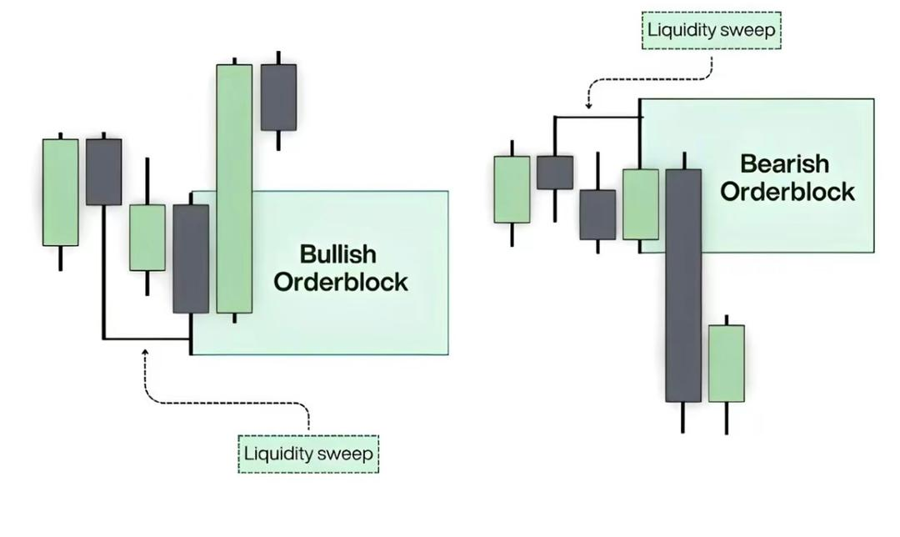

**Supply & Demand:**

Areas where there is excess of Sellers which causes price to drop. This happens when Supply Exceeds Demand. This is where selling interest or potential is the highest.

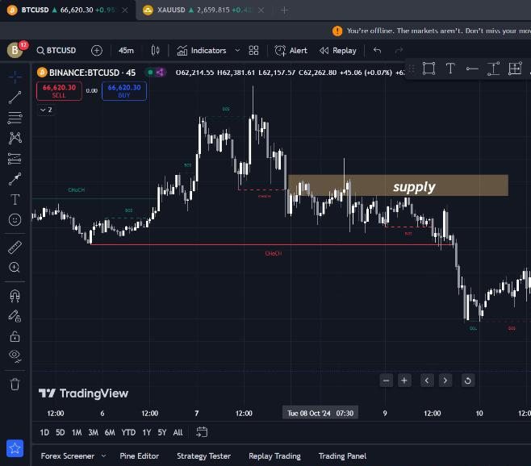

**OR**

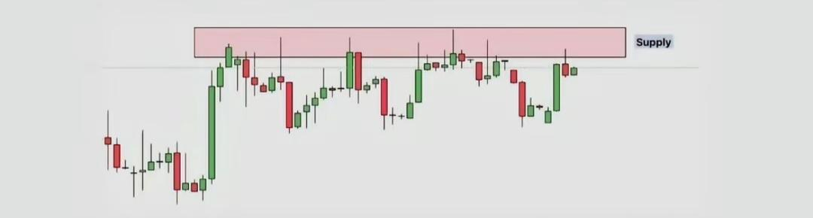

Areas where there is excess of Buyers which causes price to rise. This happens when Demand Exceeds Supply. This is where buying interest or potential is the highest.

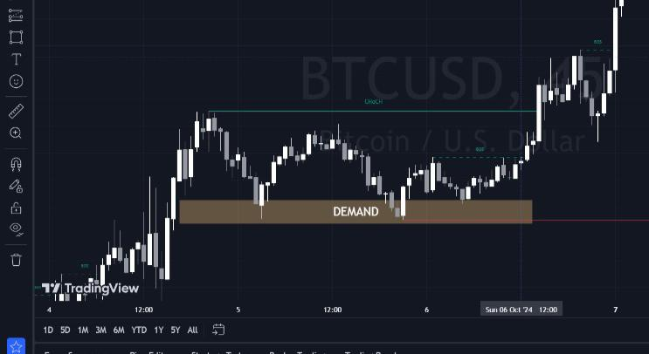

**OR**

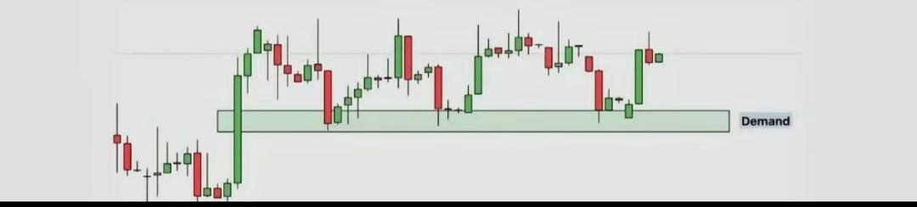

Bullish and bearish order blocks are closely related to the concepts of supply and demand in forex trading because they both represent areas where a significant imbalance between buying and selling pressure exists**.**

**ORDERBLOCK VS SUPPLY**

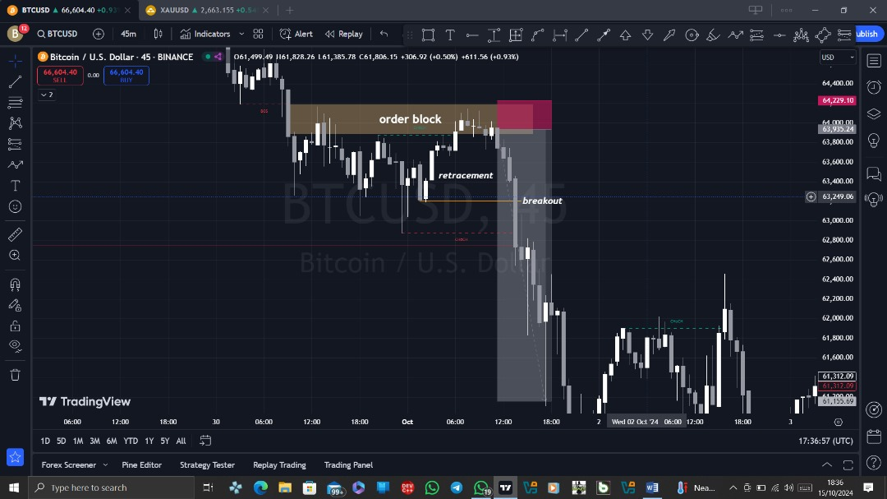

Relationship between Bullish and Bearish Order Blocks and Supply and Demand:

• Both order blocks and supply and demand zones are used to find potential entry and exit points in trading and are based on the idea of price imbalances.

• They can often overlap; a supply zone might contain a bearish order block, and a demand zone might contain a bullish order block

Reasons Why Order Blocks and Supply and Demand Are Not the Same:

Order Block: Identified by certain price patterns, such as large bullish or bearish candles, that signal strong institutional buying or selling. These blocks are often found at the origin of sharp price movements. Used by traders to follow the potential actions of institutions, aiming to align with "smart money." Traders use order blocks to enter trades where they believe institutions are accumulating (buying) or distributing (selling).

• Supply and Demand Zones: Identified by areas where the price has historically turned around or paused, indicating a high level of buying (demand) or selling (supply) pressure.

They are often wider areas on a price chart rather than specific levels.

Used by traders to identify areas where the market might reverse or continue, regardless of who is trading. These zones are considered key support or resistance areas where price reactions are likely.

**HEADANDSHOULDERS**

Head and Shoulders is a candlestick combination that consists of 4 elements-left shoulder, head and right shoulder, formed price highs, and the neckline, which is the support line for them.

In this case, the left and right shoulders are approximately at the same level, the head is above the left and right shoulders.

To make it clearer let's look at it with an example.

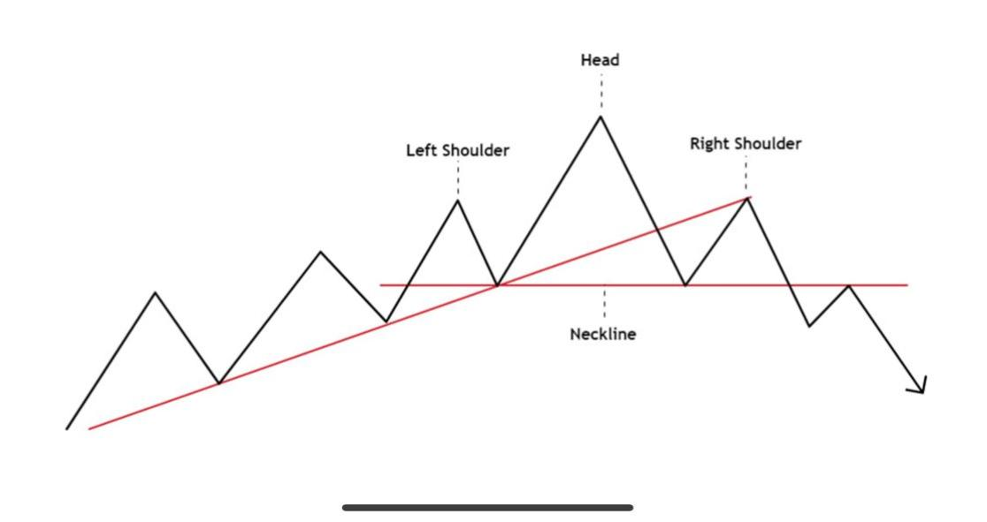

OR

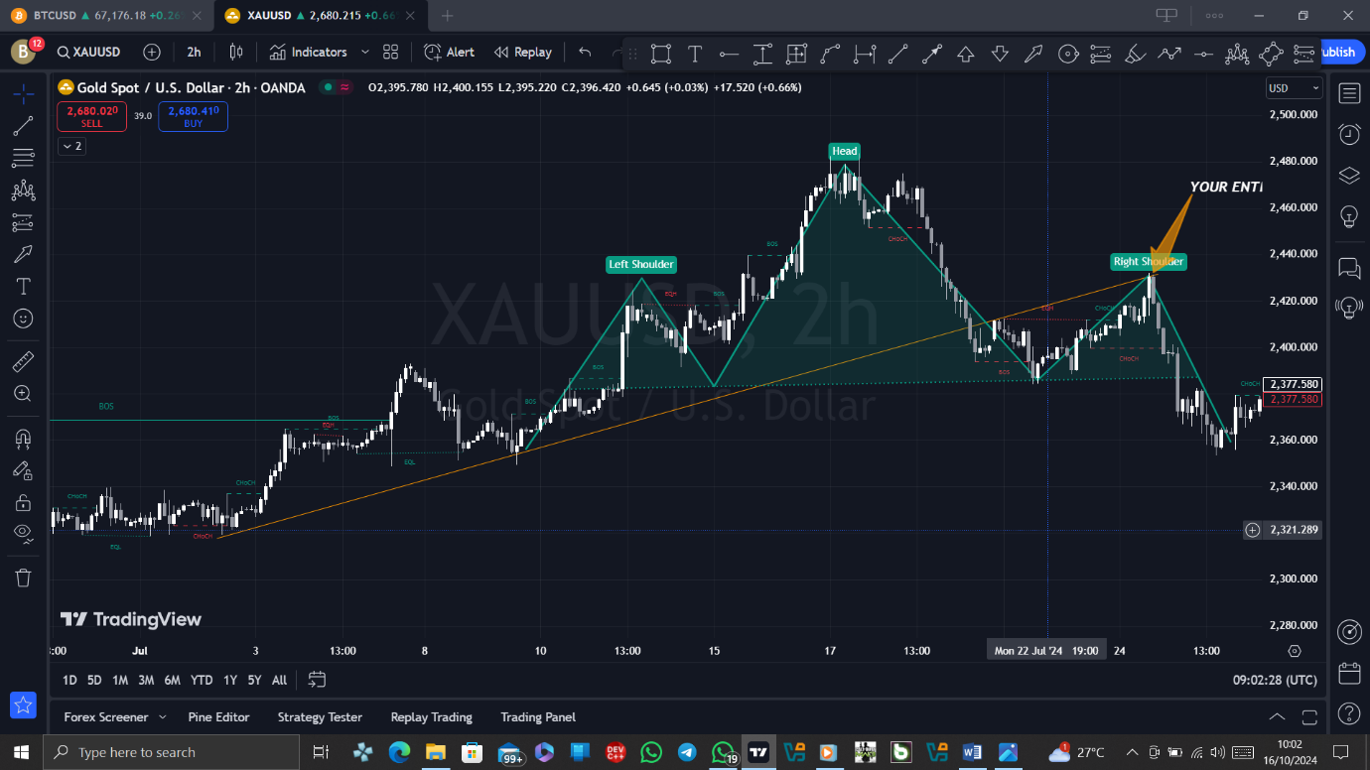

**INVERTED HEAD AND SHOULDERS**

The Inverted Head and Shoulders is a similar formation, but turned upside down. In this case, the head should be below the shoulders.

An inverted H&S is formed on a downtrend and reverses it in an upward direction. All rules for forming and opening positions are saved as a mirror image.

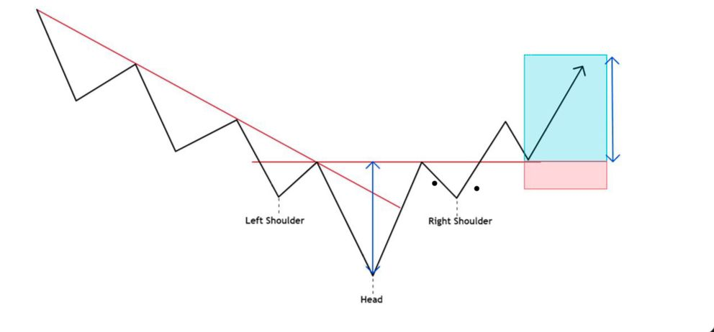

**A *trendline breakout trading strategy**\* is a popular technique used by traders to identify potential price reversals or continuations based on the breaking of trendlines. The basic idea is that a price break through a significant trendline (either upward or downward) signals a shift in market momentum, potentially indicating a strong buying or selling opportunity.

**Key Components of a Trendline Breakout Strategy:**

1. *Identifying the Trendline:*

- A *trendline* is drawn by connecting two or more swing highs (for a downward trendline) or swing lows (for an upward trendline).

- The more points the trendline touches, the more significant it becomes.

- Use higher time frames (like 4-hour or daily charts) to draw trendlines to filter out market noise.

2. *Breakout Confirmation:*

- A *breakout* occurs when the price closes beyond the trendline (either above or below, depending on the trend).

- Look for a *close* beyond the trendline, rather than just a touch or intraday break, to avoid false breakouts.

- Confirm with volume: High trading volume during the breakout adds confidence that the move is legitimate.

3. *Entry Point:*

- After the trendline is broken, you can enter the trade:

- *Aggressive Entry*: Enter immediately after the breakout candle closes.

- *Conservative Entry*: Wait for a retest of the broken trendline, which often acts as a support or resistance level after the breakout.

4. *Stop Loss Placement:*

- Place the *stop loss* just outside the trendline:

- For a *bullish breakout*, place the stop loss below the trendline or the most recent swing low.

- For a *bearish breakout*, place the stop above the trendline or the most recent swing high.

- This protects you from false breakouts and reduces potential losses.

5. *Take Profit Targets:*

- Use a *risk-reward ratio* of at least 1:2 or higher. For example, if you risk $100, aim to make at least $200.

- You can also use previous support/resistance levels or Fibonacci extensions to set your profit targets.

- Some traders use *trailing stops* to lock in profits as the trade moves in their favor.

6. *Additional Confirmation Indicators (optional):*

- To increase the probability of a successful breakout, traders often use additional indicators like:

- *RSI (Relative Strength Index)*: Look for overbought/oversold levels to confirm momentum.

- *MACD (Moving Average Convergence Divergence)*: Signals potential trend reversals.

- *Volume*: A spike in volume can confirm the strength of the breakout.

**Example of a Trendline Breakout Strategy:**

1. *Uptrend Breakout Example (Bullish)*

- Identify a *downward trendline* by connecting swing highs in a corrective move.

- Wait for a strong *bullish breakout candle* to close above the trendline.

- Enter the trade when the candle closes.

- Place a *stop loss* below the broken trendline.

- Set a *profit target* at the next significant resistance level or based on a risk-reward ratio.

2. *Downtrend Breakout Example (Bearish)*

- Identify an *upward trendline* by connecting swing lows in an uptrend.

- Wait for a *bearish breakout* candle to close below the trendline.

- Enter the trade after the candle closes below the trendline.

- Place a *stop loss* just above the broken trendline.

- Set your *profit target* at a previous support level or using a risk-reward ratio.

Key Considerations:

- *False Breakouts*: Be cautious of false breakouts where price temporarily breaches the trendline but then reverses. Confirm breakouts with volume or other indicators.

- *Timeframes*: Higher time frames (4-hour, daily, or weekly) provide stronger and more reliable trendlines, while shorter timeframes may lead to more false signals.

- *Market Conditions*: Trendline breakout strategies work best in trending markets. In a range-bound or sideways market, breakouts may be less reliable.

**Conclusion:**

The trendline breakout strategy is straightforward but powerful, offering clear buy/sell signals based on price action. Combining this method with other technical indicators can improve its reliability and help you better manage risk in your trades.

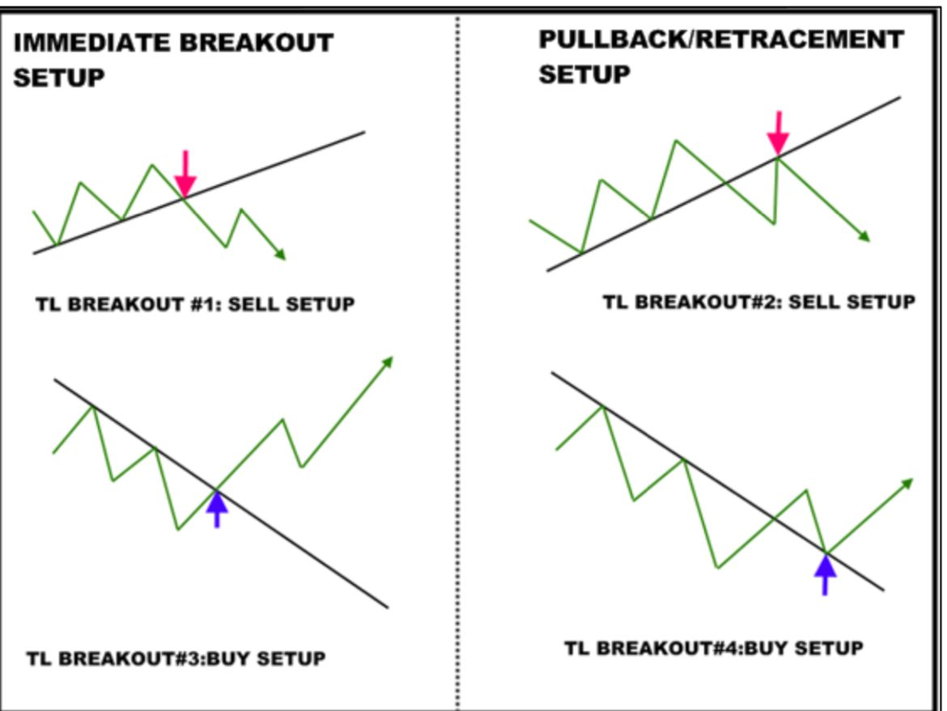

OR

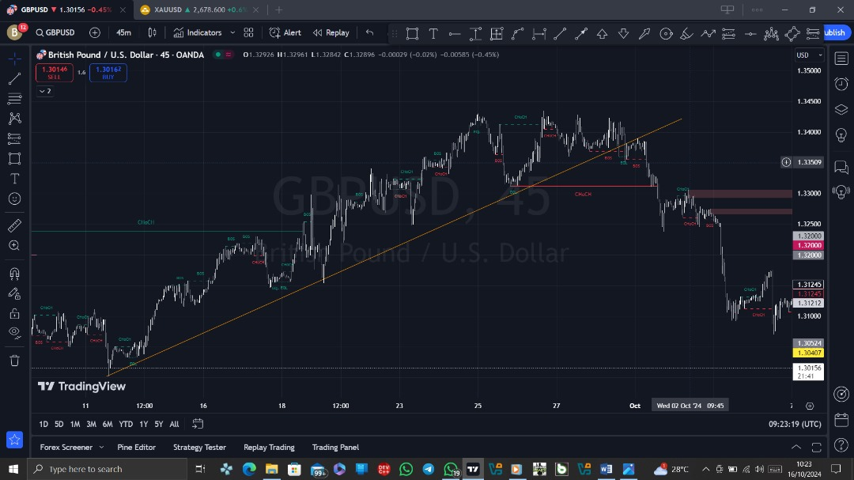

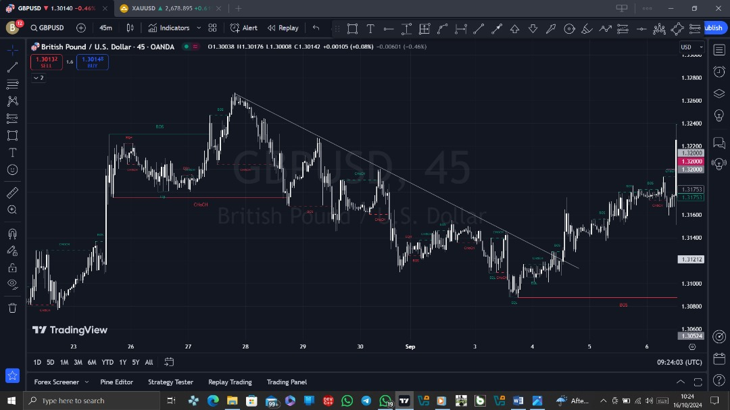

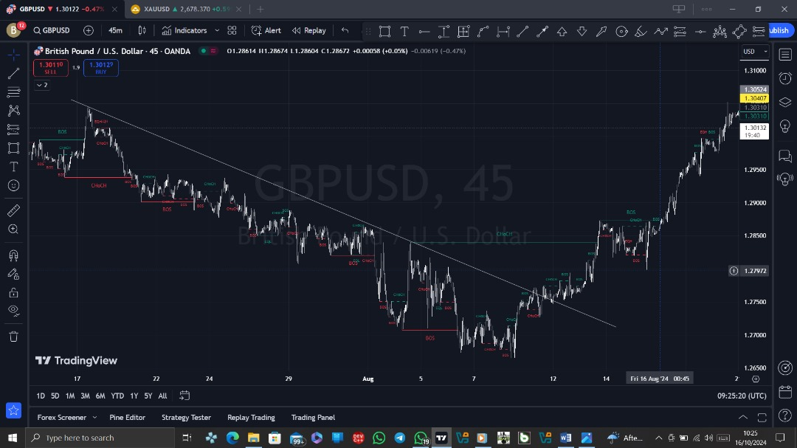

**Trading terms you should know**:

PDH: Previous Day High

PDL: Previous Day Low

SL: Stop Loss

TP: Take Profit

BE: Break Even

NYO: New York Open

OB: Order Block

BB: Breaker Block

MB: Mitigation Block

RB: Rejection Block

FVG: Fair Value Gap

IFVG: Inversion FVG

VI: Volume Imbalance

CE: Consequent Encroachment

MT: Mean Threshold

LS: Liquidity Sweep

MSS: Market Structure Shift

BOS: Break of Structure

SMT: Smart Money Technique

SSL: Sellside Liquidity

BSL: Buyside Liquidity

IRL: Internal Range Liquidity

ERL: External Range Liquidity

EQL: Equal Lows

EQH: Equal Highs

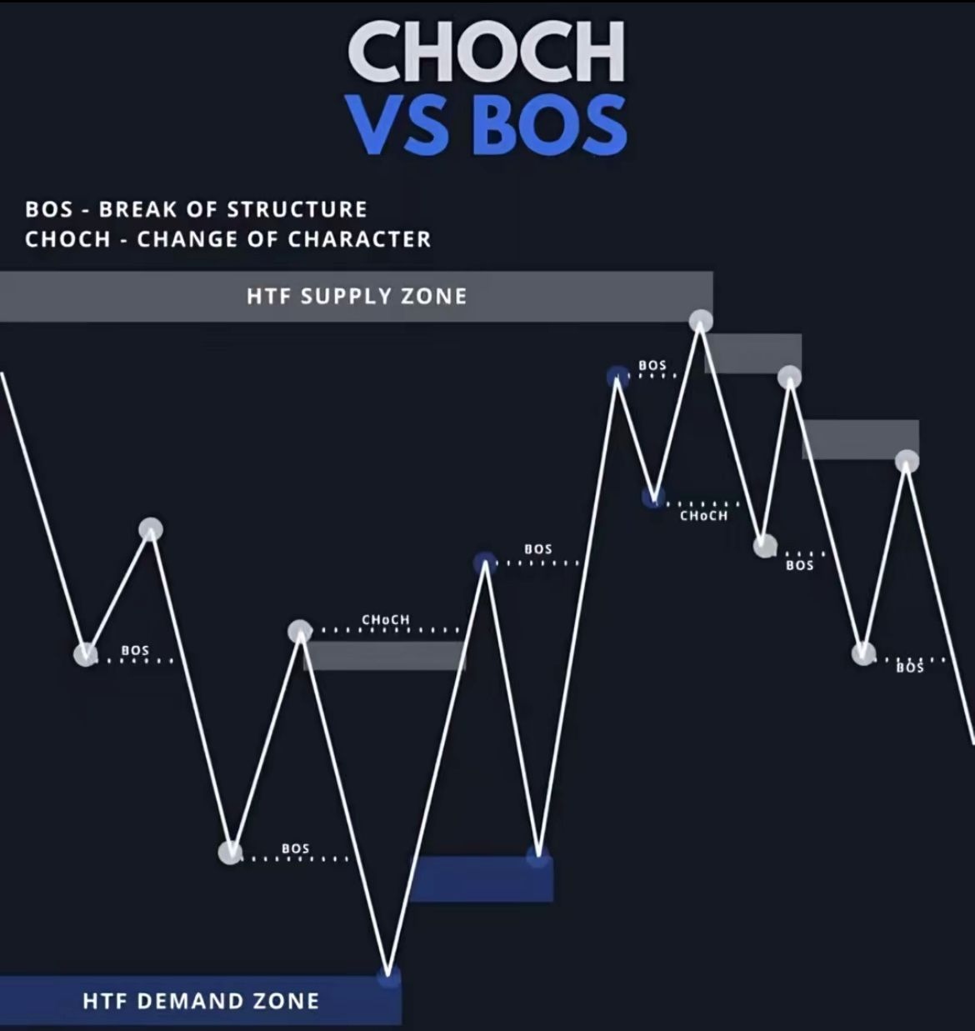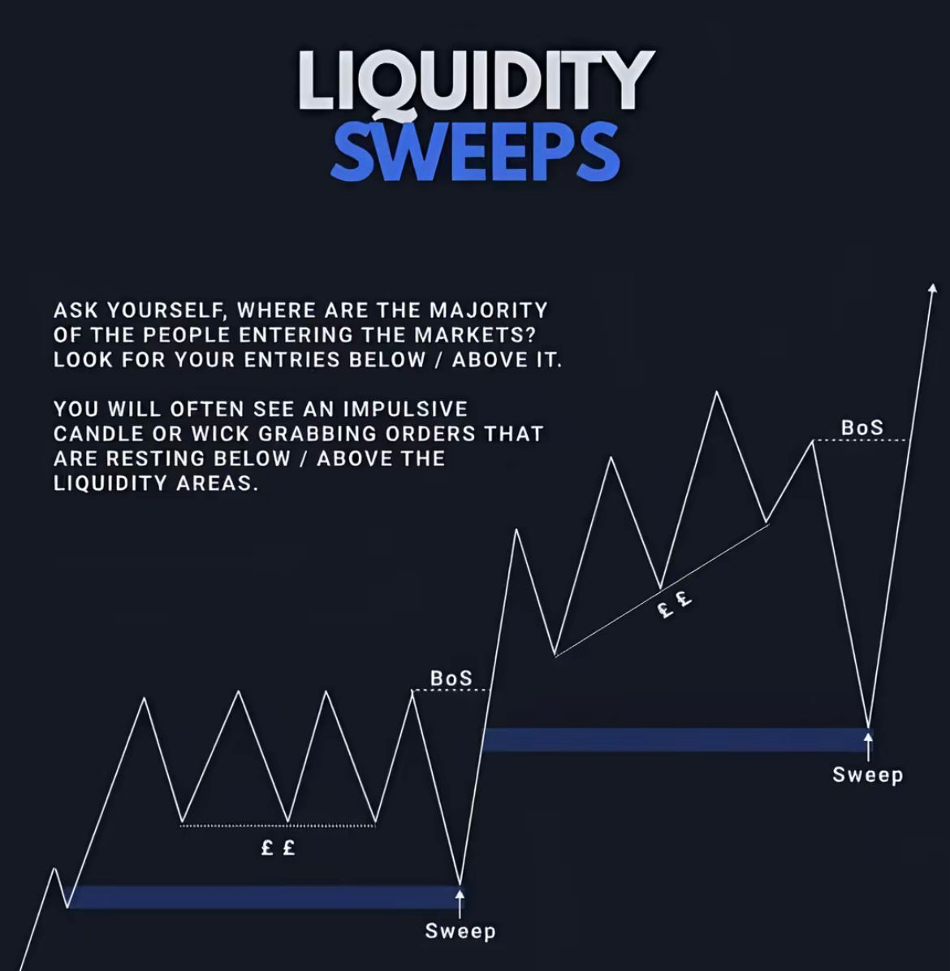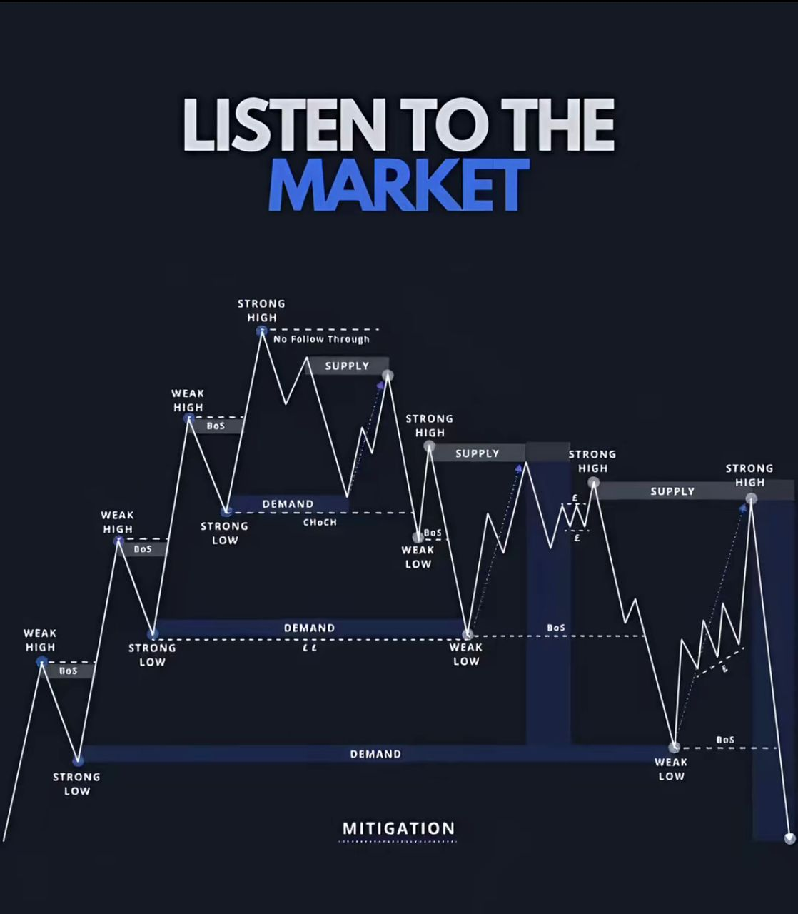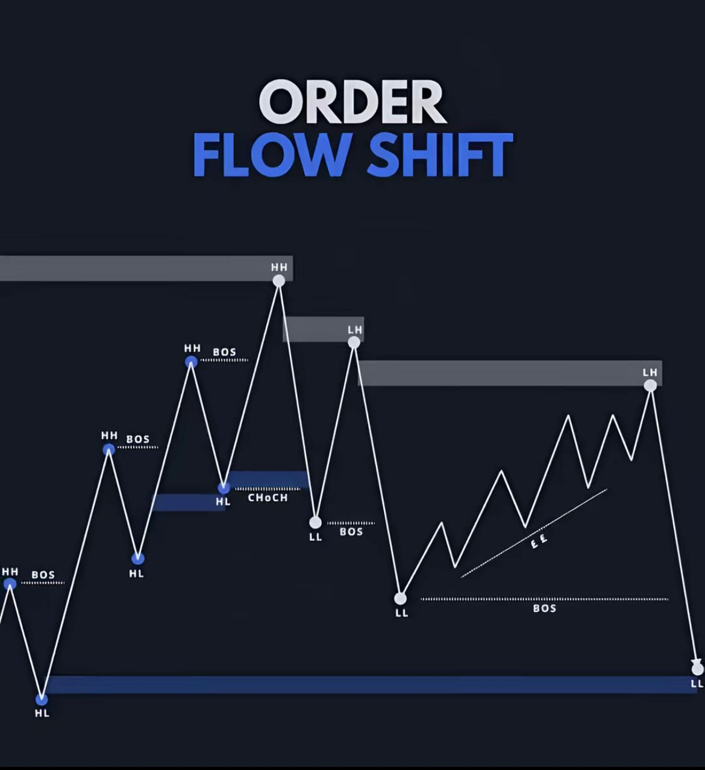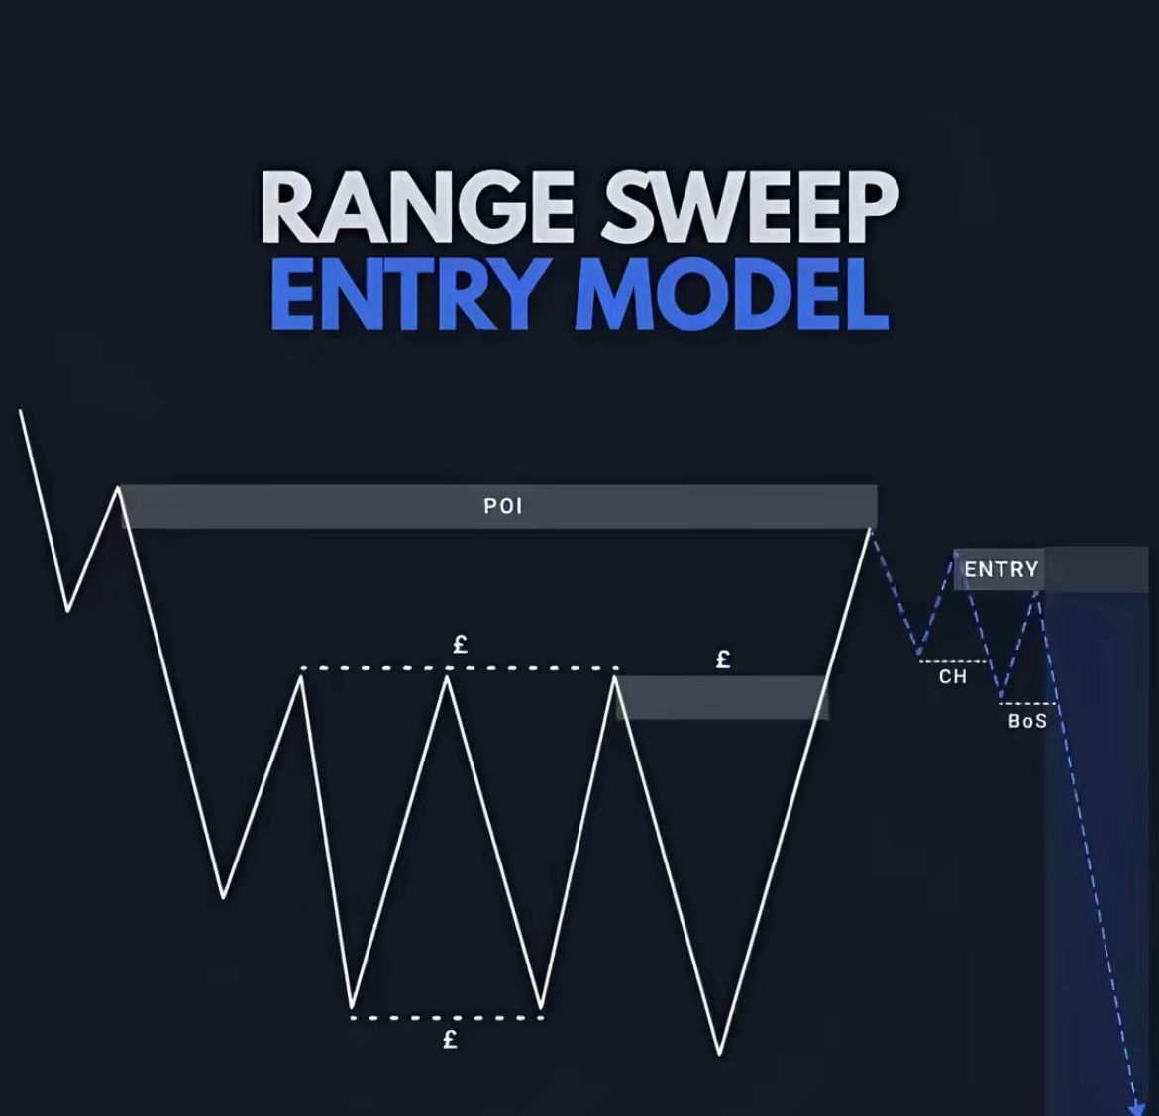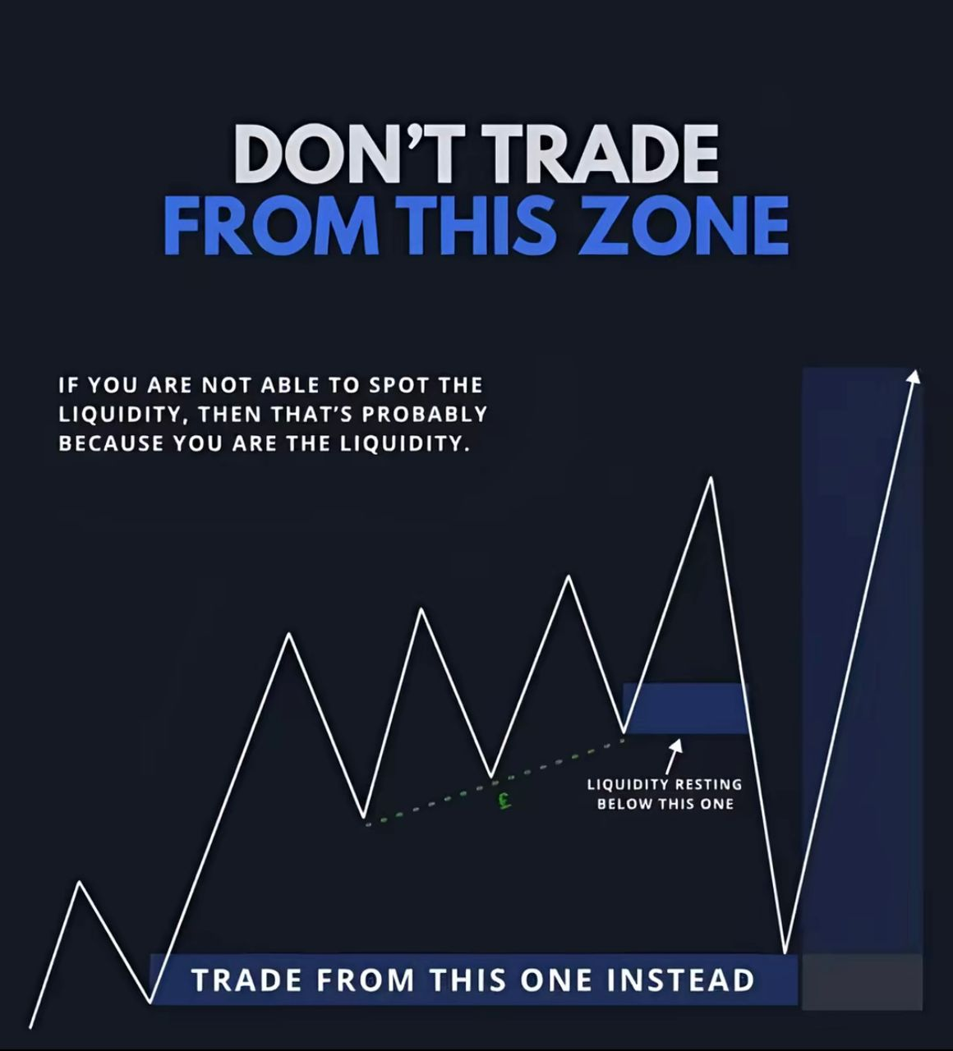

**Let talk about Liquidity:**

LIQUIDITY=STOPLOSS=MONEY

• LIQUIDITY

Liquidity is where, there are lots of stoplosses/money and most people are looking to take trades.

Tons of stoploss=liquidity zones

I move the price where there is lot of stoplos (liquidity zones, taking them out before moving

market moves based on price manipulation and to be there price manipulation in order to obtain liquidity.

Every top and bottom in a market is liquidity.

**Types of liquidity:**

* Major liquidity

* Medium liquidity

* Minor liquidity

* Liquidity transfer

* Liquidity models

* Spot the liquidity

* External and internal liquidity

* Range high & range low liquidity (liquidity building)

* Liquidity examples

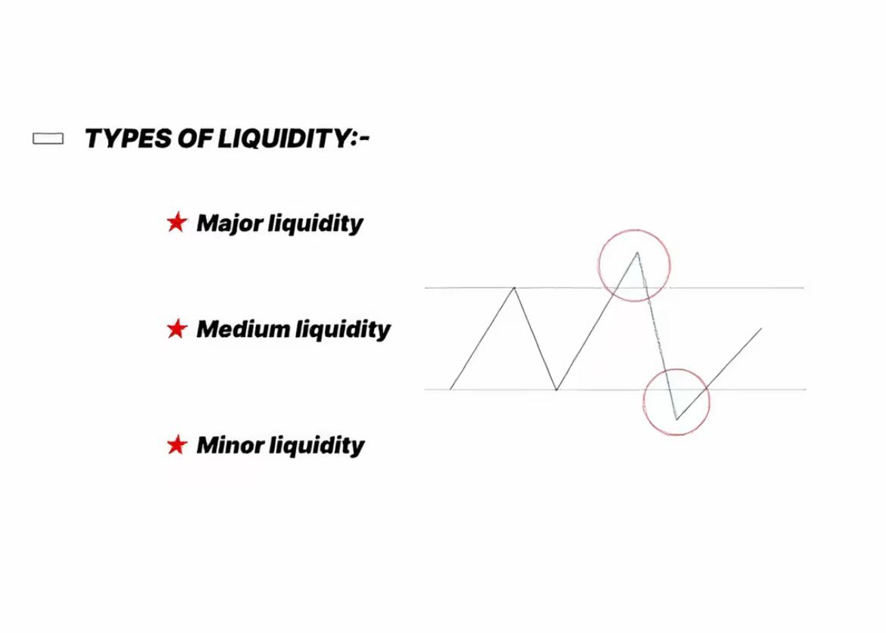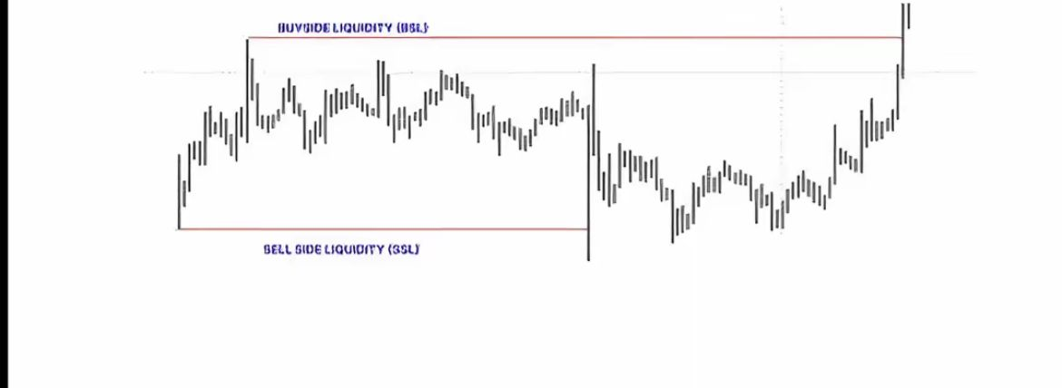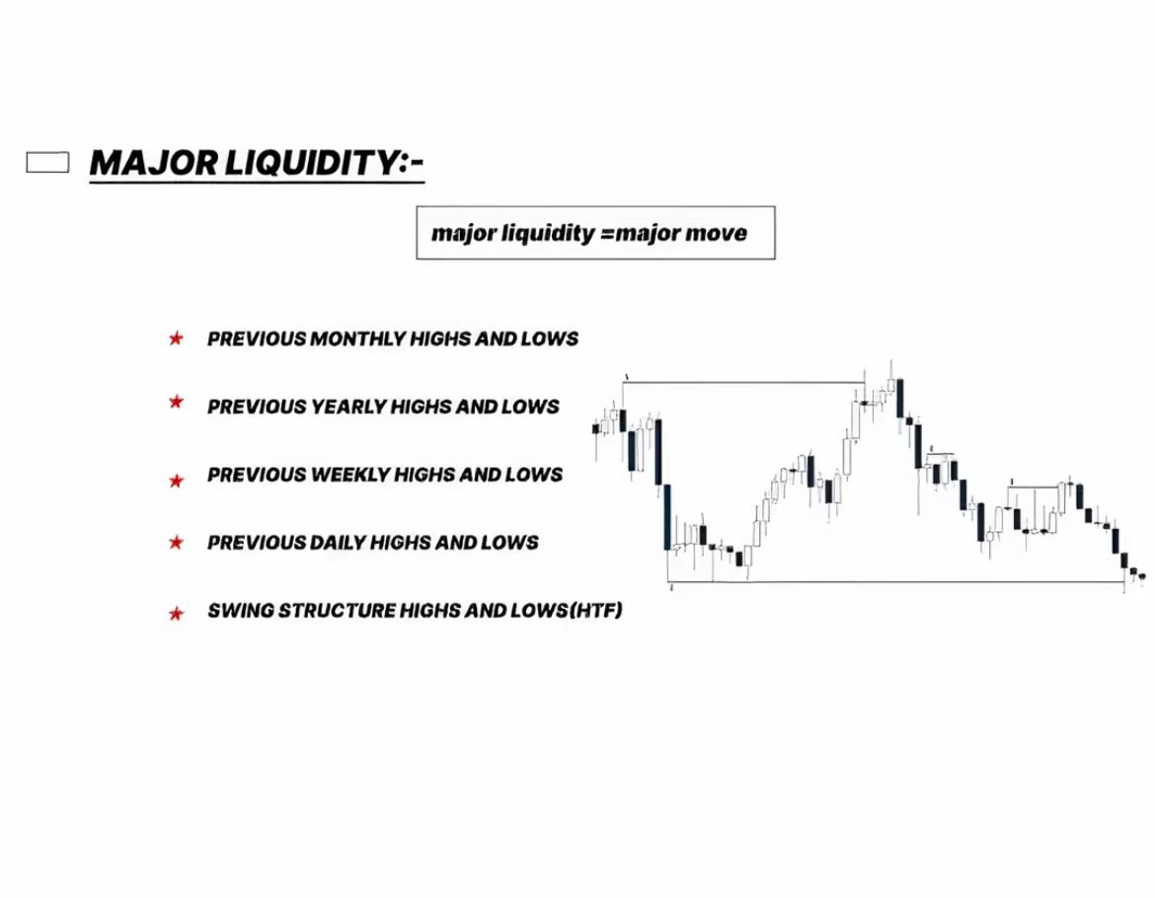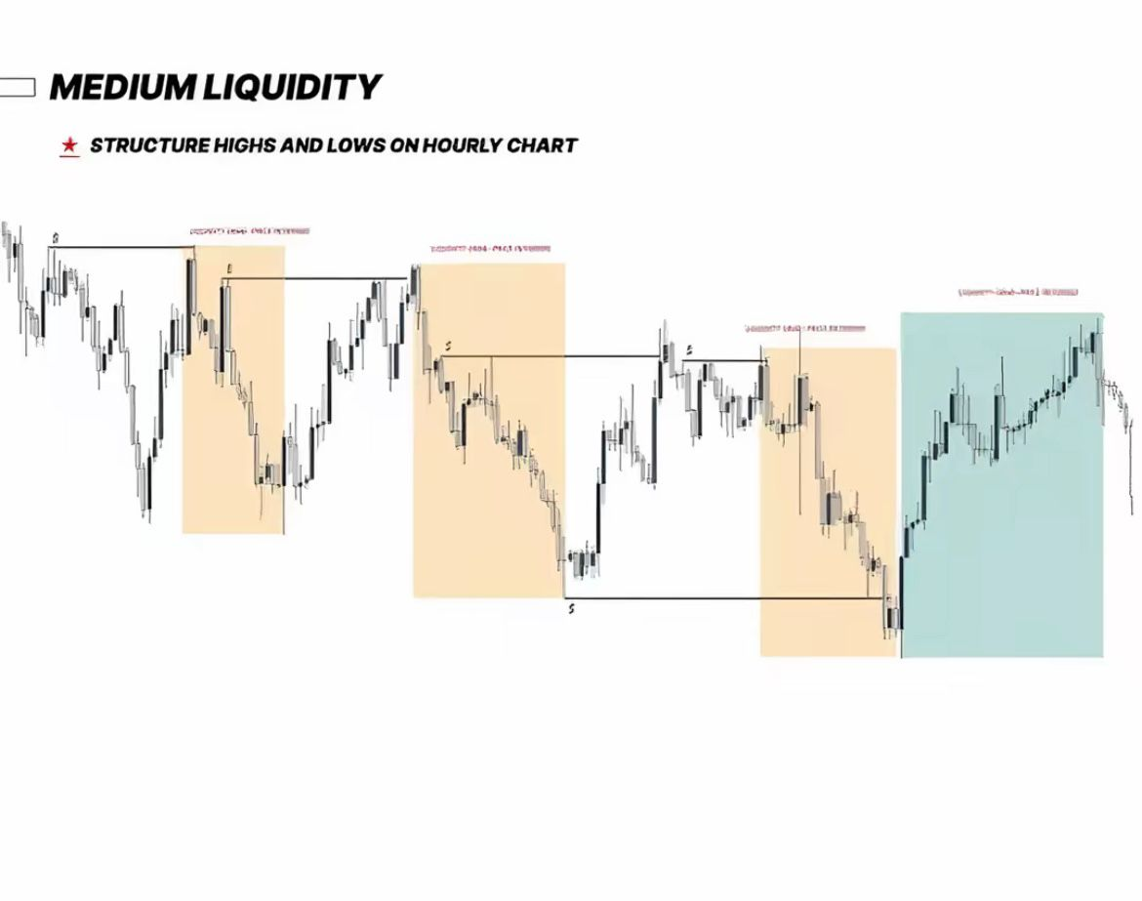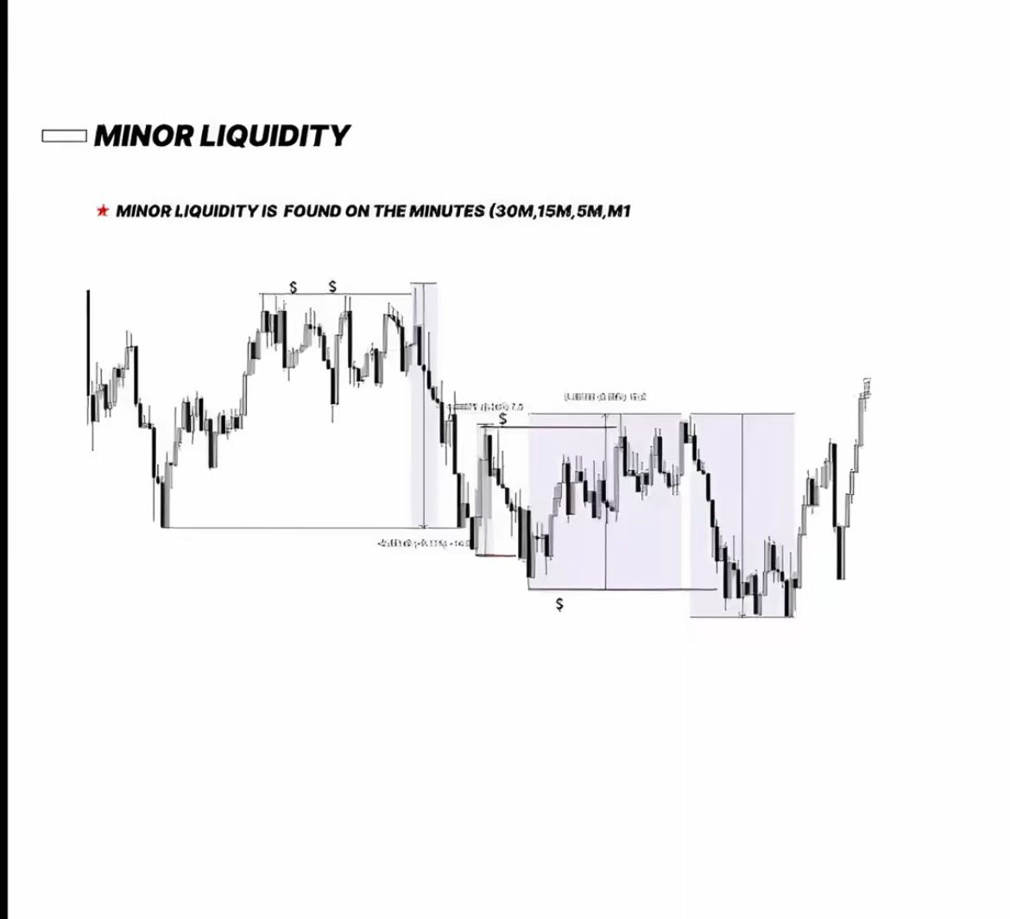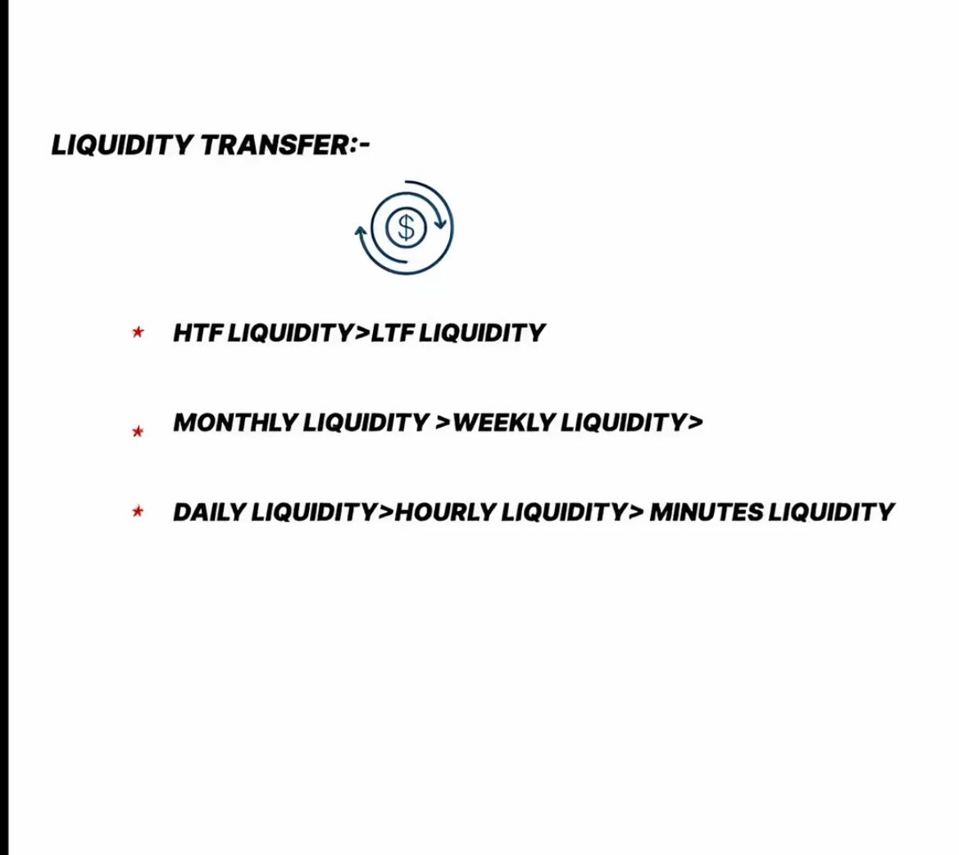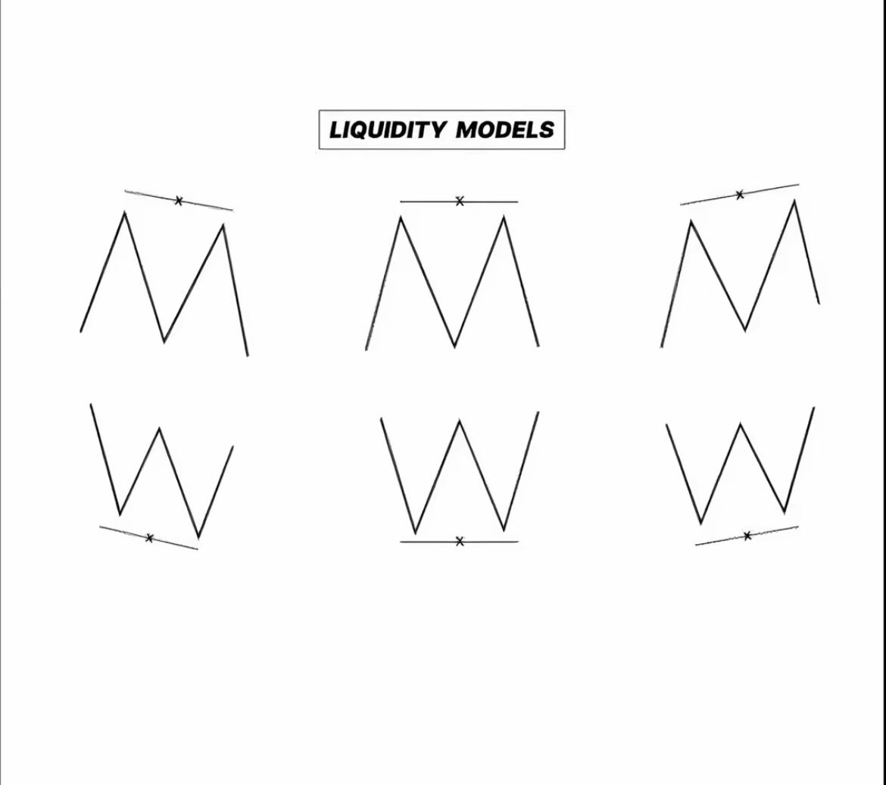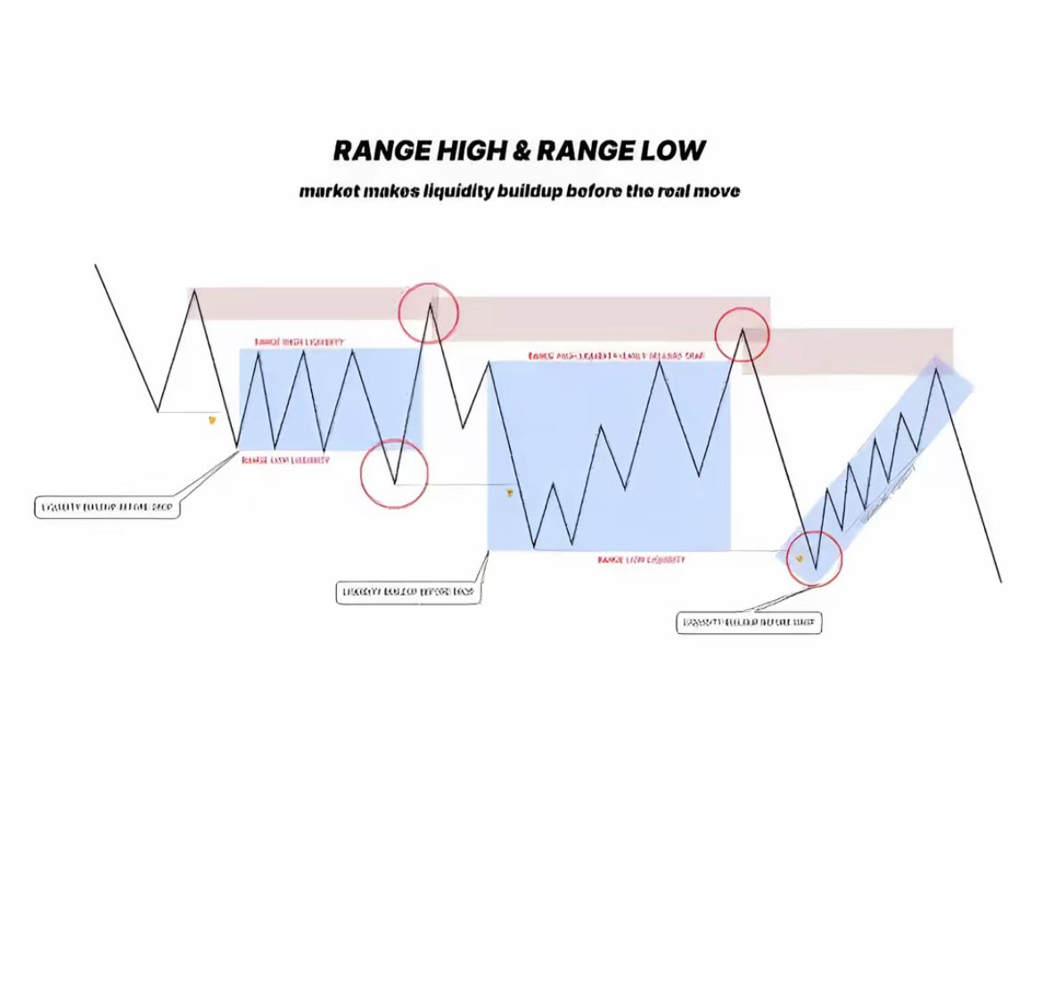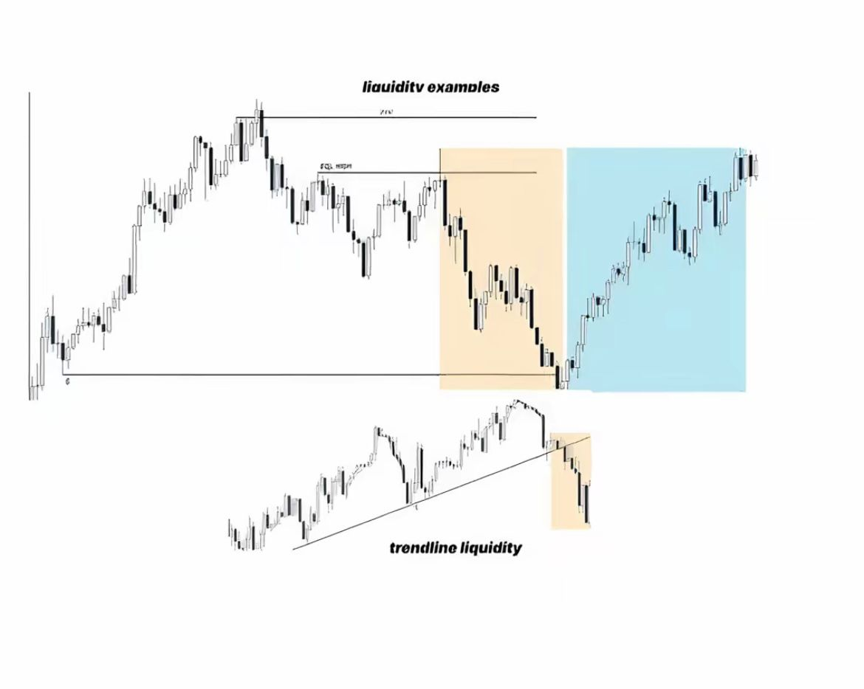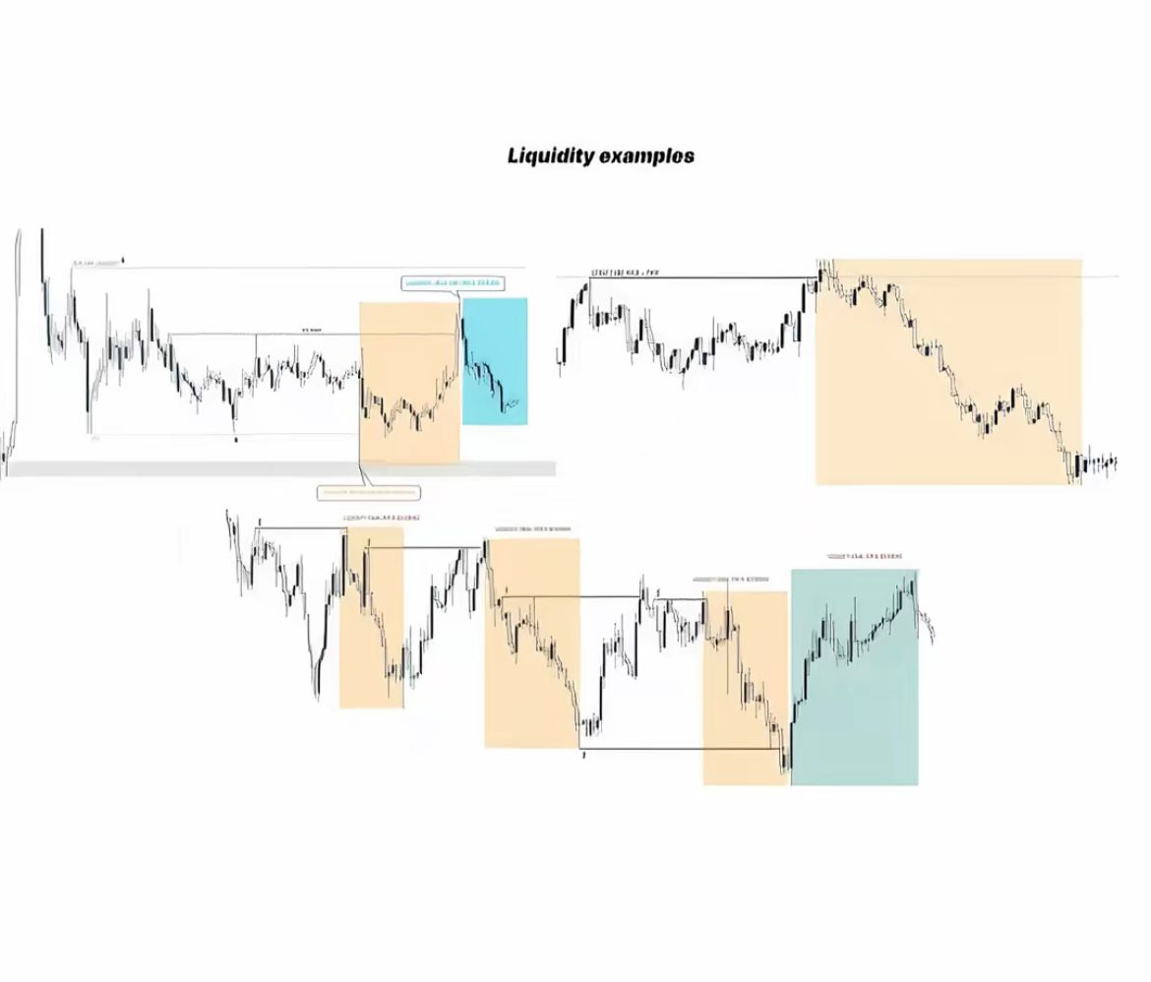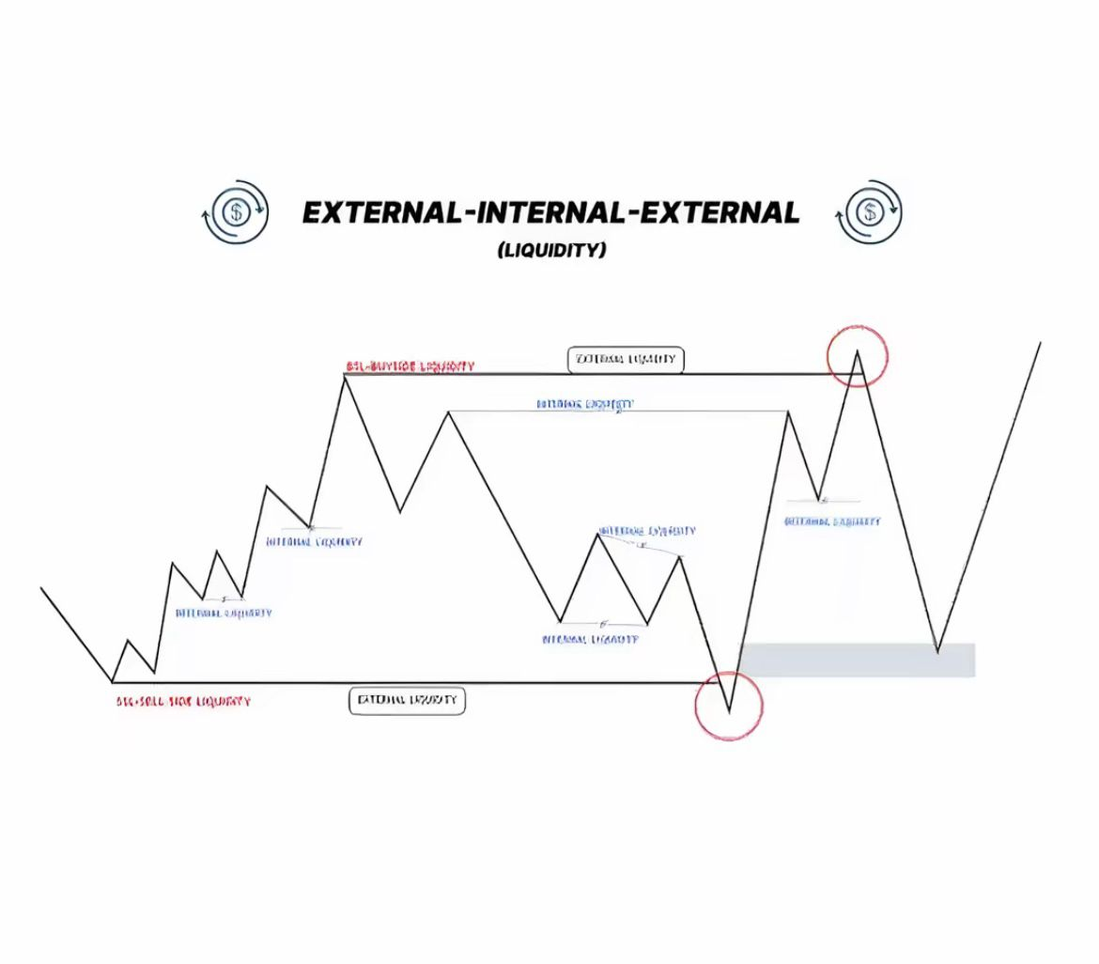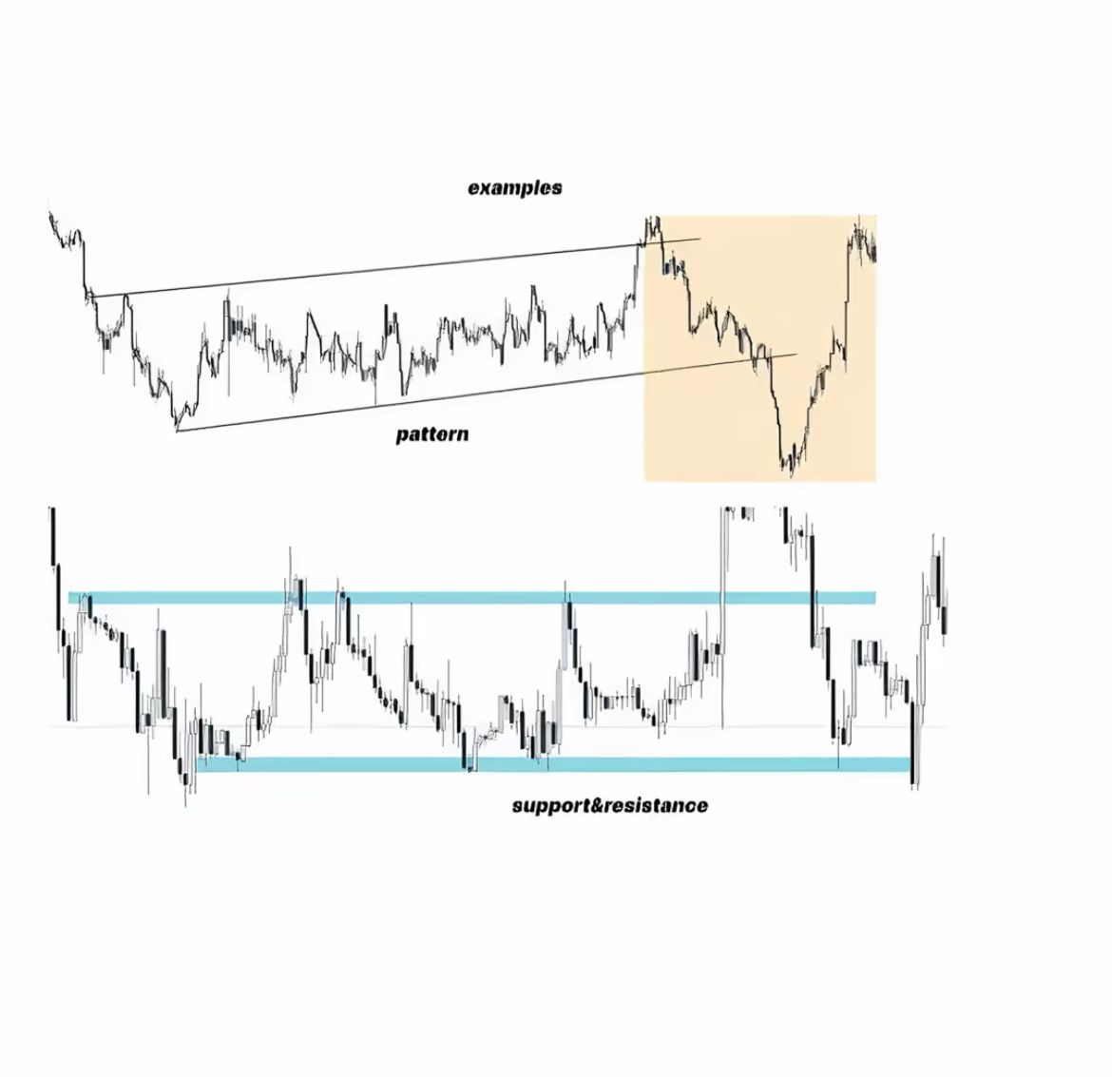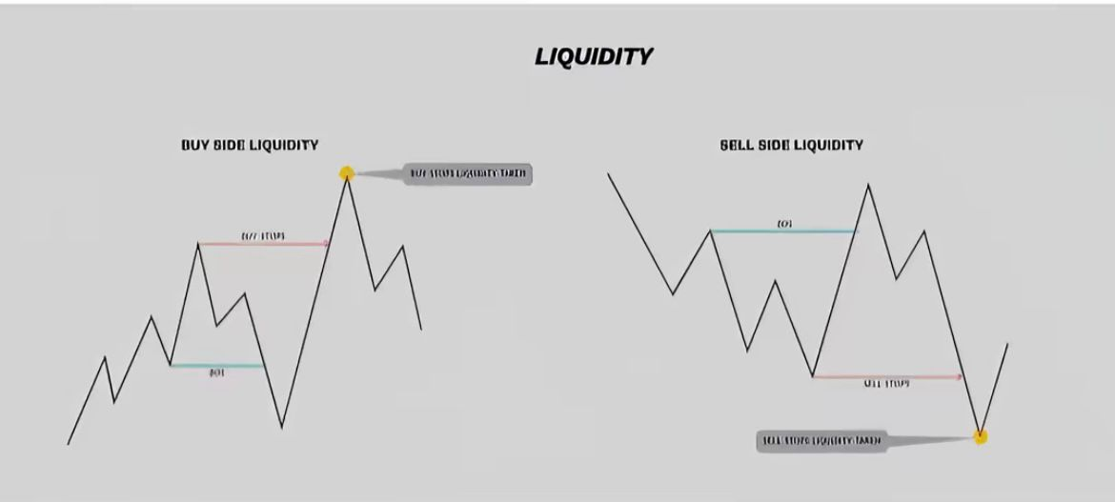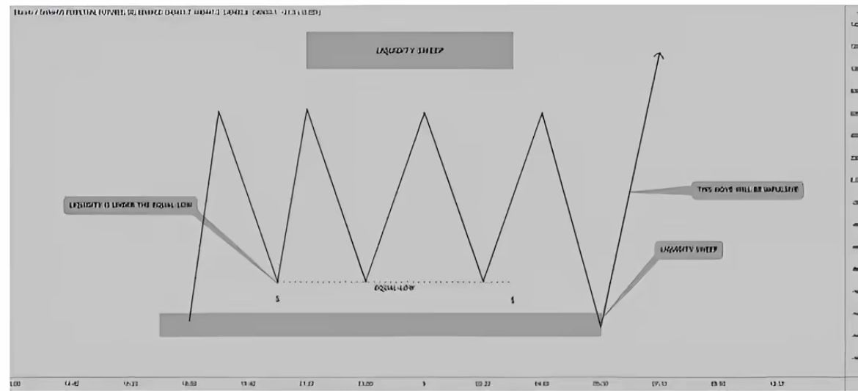

Thank you.